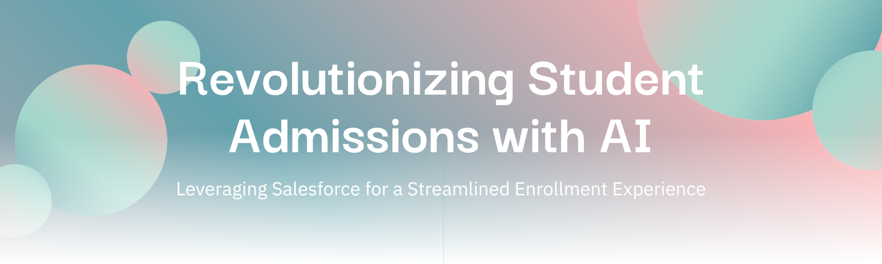
Project Documentation: AI-Enabled Student Admission System
This document provides a detailed plan for implementing the AI-Enabled Student Admission System using Salesforce. The focus is on leveraging declarative configurations with minimal coding to streamline the student admissions process. This comprehensive documentation includes diagrams and step-by-step instructions for each milestone, along with a suggested data model.
Table of Contents
- Introduction
- Business Context
- Immediate Actions – High-Level Phases
- Detailed Milestone Checklist
- Deployment
- Monitoring & Post-Deployment
- Guidelines for Project Documentation
- Use of Cursor / Anti-Gravity to Speed Up
- Final Tips to Finish ASAP
- Next Steps

1. Introduction
This document is intended to guide the development of a Salesforce-based AI-Enabled Student Admission System, focusing on automating the admission process from initial application to final enrollment. It includes detailed steps and diagrams to aid in understanding and execution.

2. Business Context
Goal
Automate the student admission process, covering application submission, evaluation, approval, and registration.
Key Entities
- Applicant: Represents the student, using a Person Account or Contact.
- Application: Custom object containing program details, status, and documents.
- Program: Custom object listing available courses or departments.
- Review: Custom object for internal evaluation scores and comments.
Process Overview
- Applicant submits an application.
- Automatic assignment to a reviewer.
- Review and scoring of the application.
- Approval or rejection of the application.
- Offer letter sent to the applicant.
- Student enrollment upon acceptance.

3. Immediate Actions – High-Level Phases
Phase | Milestones | Actions
Phase 1 – Requirements | Understanding Business Requirements; Defining Scope | Write a 1-page document summarizing the business context.
Phase 2 – Backend Config | Account, Objects, Tabs, Fields, Validation, Approval, Email, Flows | Configure all declarative items.
Phase 3 – UI/UX | Lightning App, Page Layouts, Dynamic Forms | Build a custom Lightning App with tailored record pages.
Phase 4 – Security & Testing | Duplicate Rules, Profiles, Roles | Set up sharing and duplicate prevention.
Phase 5 – Deployment | Deployment, Monitoring, Documentation | Deploy and write final documentation.

4. Detailed Milestone Checklist
Milestone 1: Salesforce Account
- [ ] Create a Developer Edition or use an existing Trailhead playground.
- [ ] Document your Org ID and Username.
Milestone 2: Objects Creation
Create the following Custom Objects:
- Program__c: Fields include Name, Description, Capacity, Department.
- Application__c: Fields include Applicant (Lookup to Contact), Program (Lookup to Program__c), Status, Submission_Date, Decision_Date, Comments.
- Review__c: Fields include Application (Master-Detail to Application__c), Reviewer (Lookup to User), Score, Remarks.
Milestone 3: Tabs
- Create Custom Object Tabs for each object and add them to the app.
Milestone 4: Fields & Relationships
- Add required fields with appropriate data types.
- Set up Lookup/Master-Detail relationships:
  - Application → Contact (Lookup)
  - Application → Program (Lookup)
  - Review → Application (Master-Detail)
- Add Roll-Up Summary on Application to average Review Scores.
Milestone 5: Validation Rules
Create these validation rules on Application__c:
- Submission Date cannot be future: Submission_Date__c <= TODAY()
- Decision Date must be after Submission Date: Decision_Date__c >= Submission_Date__c
- Status cannot be changed from Approved to Rejected: ISPICKVAL(PRIORVALUE(Status__c), "Approved") && ISPICKVAL(Status__c, "Rejected")
- For Program, ensure Capacity > 0 on insert/update.
Milestone 6: Approval Process
Build an Approval Process on Application__c:
- Criteria: Status = Submitted.
- Assign to a Reviewer.
- Final approval sets Status = Approved; rejection sets Status = Rejected.
- Include email notifications.
Milestone 7: Email Templates
Create HTML/Text Email Templates for:
- Application Received
- Application Under Review
- Decision Notification
Milestone 8: Email Alerts
Associate Email Alerts with the Approval Process or a Flow.
Milestone 9: Declarative Automation (Flows)
Build a Record-Triggered Flow to automate tasks when Application status changes to “Submitted”.
Milestone 10: Agentforce AI
Document a use-case for Einstein/Agentforce features, such as predicting admission likelihood.
Milestone 11: The Lightning App
Create a Lightning App named “Student Admission” with custom tabs.
Milestone 12: Page Layouts
Customize Page Layouts for each object with key fields and related lists.
Milestone 13: Dynamic Forms
Convert the Application layout to Dynamic Forms and use Visibility Rules.
Milestone 14: Users
Create at least 3 Users: Admission Officer, Reviewer, Applicant. Assign appropriate roles.
Milestone 15: Duplicate & Matching Rules
Create a Duplicate Rule on Contact to prevent duplicate applicants.
Milestone 16: Profiles
Clone the Standard User profile to create profiles for different roles.
Milestone 17: Roles & Role Hierarchy
Build a role hierarchy. Enable Role-based sharing.

5. Deployment
- Use Change Sets or Salesforce DX to deploy configurations.
- Document the deployment steps.

6. Monitoring & Post-Deployment
- Set up Debug Logs and Einstein Activity Capture.
- Write a “Maintenance Plan” for monitoring and handling errors.

7. Guidelines for Project Documentation
- Write a comprehensive report covering requirements, scope, object model, configurations, testing evidence, and deployment steps.

8. Use of Cursor / Anti-Gravity to Speed Up
- Validation Rules & Formula Fields: Use Cursor to generate formula syntax.
- Flows: Describe logic in plain English, and use Cursor for Flow XML.

9. Final Tips to Finish ASAP
- Skip complex AI – demonstrate basic integration.
- Use sample data – create a few dummy records.
- Prioritize – focus on core objects, fields, validation, approval, and flows.
- Screenshots – capture while configuring.
- Time estimate – complete in 3-4 hours with focused work.

10. Next Steps
Start with Milestone 1-4 to create your org and objects, then proceed with validation and approval. Leave AI and Dynamic Forms for last.

